Stem Cells Allow Nearly Blind Patients to See

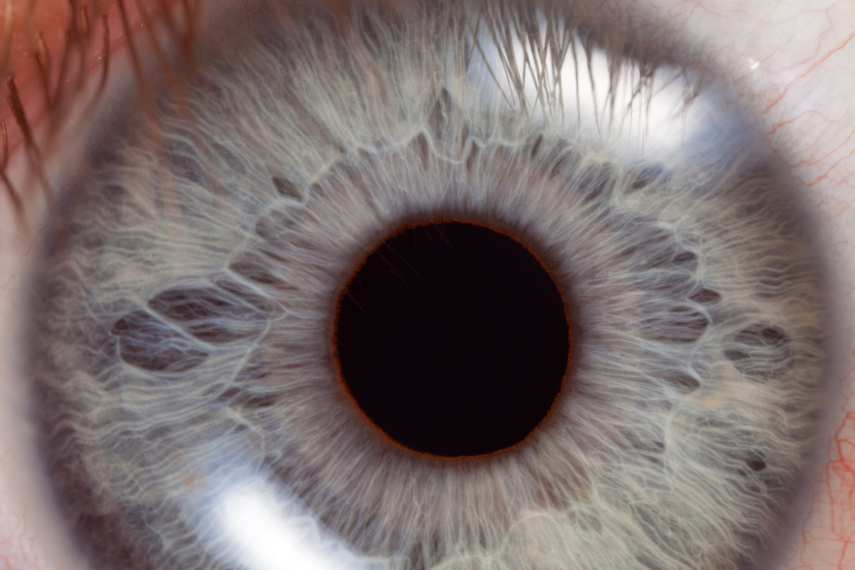

Embryonic stem cells can be turned into a therapy to help the sight of the nearly blind
In a report published in the journal Lancet, scientists led by Dr. Robert Lanza, chief scientific officer atAdvanced Cell Technology, provide the first evidence that stem cells from human embryos can be a safe and effective source of therapies for two types of eye diseases—age-related macular degeneration, the most common cause of vision loss in people over age 60, and Stargardt’s macular dystrophy, a rarer, inherited condition that can leave patients legally blind and only able to sense hand motions.
In the study, 18 patients with either disorder received transplants of retinal epithelial cells (RPE) made from stem cells that came from human embryos. The embryos were from IVF procedures and donated for research. Lanza and his team devised a process of treating the stem cells so they could turn into the RPE cells. In patients with macular degeneration, these are the cells responsible for their vision loss; normally they help to keep the nerve cells that sense light in the retina healthy and functioning properly, but in those with macular degeneration or Stargardt’s, they start to deteriorate. Without RPE cells, the nerves then start to die, leading to gradual vision loss.
Dr. Steven Schwartz had been waiting 14 years to make the phone call. As an eye doctor at the University of California, Los Angeles, Schwartz sees his share of patients with serious diseases that slowly rob them of their sight. Yet when a 12-year-old girl went to him complaining of vision problems, he had the difficult job of diagnosing her with Stargardt's, one of the more common forms of macular degeneration, in which the photoreceptor cells start to deteriorate. He had to tell her that the world she knew would gradually, pixel by pixel, fade into darkness and that there was nothing he could do to treat her impending blindness. He suggested she try visual aids and vitamins to keep any remaining cells functioning, but that was all he could offer. She and her family were interested in participating in research trials, however, so he promised that he would call if any new opportunities arose.
Nearly a decade and a half later, Schwartz kept that promise and phoned the patient he couldn't forget with some exciting news. He was getting ready to test the first embryonic-stem-cell therapy for Stargardt's and dry macular degeneration. Would she, he wondered, be interested in learning more?
Now 26 and legally blind, the young woman, who can't be identified until after her treatment because of informed-consent rules, immediately said yes. She is being evaluated as a potential pioneer to receive the first retinal pigment epithelium (RPE) cells generated from embryonic stem cells. If accepted, she will join a handful of other patients with macular degeneration who will have thousands of cells injected into their eyes to replace their destroyed RPE cells in the retina and, hopefully, rescue any remaining photoreceptor cells. They will help scientists answer a critical question: After all the controversy over embryonic stem cells, are therapies derived from them safe and ultimately effective?
Two patients with spinal-cord injuries have already received injections of another embryonic-stem-cell-based treatment — millions of specific cells that help neurons communicate with one another — in an effort to repair the shredded network of nerves that crisscross the spinal cord and extend out to the arms, legs, fingers and toes. While still a select group, together these patients represent the first wave of what doctors hope will be a new era in cell-based medicine. Instead of treating disease symptoms with drugs or surgery — regular insulin injections for diabetics, for instance, or medications to help break up the plaques that strangle nerve cells in the brains of Alzheimer's patients — they're hoping to replace damaged and no-longer-functioning cells with new, healthier versions that could eventually lead to a cure for countless chronic diseases, from macular degeneration to diabetes, heart disease and spinal-cord injury. And the key to generating these new cells will be stem cells.
"We are finally ready to break ground on this field with the first trials," says Dr. Robert Lanza, chief scientific officer at Advanced Cell Technology, the company that makes the RPE cells. "It's taken a decade of extensive research to get to this point."
In those 10 years, stem-cell scientists have had to address some tough questions about how realistic it would be to extract stem cells from a human embryo, coax those cells to develop into nerve and eye cells and then transplant them into patients. The burden on these vanguard trials is huge, and the questions they inspire are legion — and disturbing. Will the transplanted cells "take," escaping destruction by their new hosts' immune systems? The cells are, after all, made from embryos that were completely unrelated to the recipients. Will the fact that the cells were developed from embryonic stem cells lead them to form tumors? Embryonic stem cells are known for their ability to grow indefinitely. Left alone, such cells tend to form grotesque balls of different tissue types — bone, skin, tooth, hair, muscle — known as teratomas. And if the transplanted cells do survive and don't form tumors or teratomas, will they function properly? Will that function be enough to restore some feeling, in the case of the spinal-cord-injury patients, or some vision in the eye patients?
The transplants of RPE cells were injected directly into the space in front of the retina of each patient’s most damaged eye. The new RPE cells can’t force the formation of new nerve cells, but they can help the ones that are still there to keep functioning and doing their job to process light and help the patient to see. “Only one RPE can maintain the health of a thousand photoreceptors,” says Lanza.
The trial is the only one approved by the Food and Drug Administration involving human embryonic stem cells as a treatment. (Another, the first to gain the agency’s approval, involved using human embryonic stem cells to treat spinal cord injury, but was stopped by the company.) Because the stem cells come from unrelated donors, and because they can grow into any of the body’s many cells types, experts have been concerned about their risks, including the possibility of tumors and immune rejection.
For the researchers at UCLA’s Jules Stein Eye Institute who launched the first-ever study to show that human embryonic stem cells may help reverse patients’ disease, the history-making day began at 4:30 a.m. It was an early morning wake-up call, to be sure, but a necessary one to prepare for the groundbreaking work that lay ahead. On July 12, 2011, the scientists injected retinal cells derived from embryonic stem cells into the eyes of two patients suffering from progressive blindness, and the results announced Monday suggest that the treatment has changed their lives.
The international group of doctors and researchers involved in the safety trial, sponsored by Advanced Cell Technology (ACT), which produced the retinal cells, report in the journal Lancet that the patients who received the therapy are doing well, showing no signs of adverse effects from the treatment and even reporting small improvements in their vision. So far, 24 additional patients are expected to receive the same treatment.
The early results represent an important milestone for the field of embryonic stem cell research, which suffered a blow last year when Geron Corp. halted the first and only other U.S. government-approved stem cell trial in humans — for spinal cord injury patients — and announced that it would no longer pursue stem cell research due to financial reasons. ACT’s findings, while still preliminary, could pave the way for similar trials in the future and revive enthusiasm for the stem cell field. Many researchers hope that replacing diseased cells with healthy ones made from embryonic stem cells will someday become standard treatment for conditions such as diabetes, Alzheimer’s or spinal cord injury.
“This is very important for the field of human embryonic stem cell research,” says Dr. Steven Schwartz, director of the Diabetic Eye Disease and Retinal Vascular Center at UCLA and lead author of the paper. “It opens the door for multiple strategies in the field, and hopefully for everyone investigating [this technique], it puts some wind in their sails.”
“This is the first report of human embryonic stem cell-derived cells transplanted into patients, and the safety and engraftment data to date look very encouraging,” co-author Dr. Robert Lanza, chief scientific officer of ACT, said in a statement. “It has provided the scientific community with important data and experience that will help advanced efforts in the regenerative medicine field.”
The first patient to receive the retinal cells was Sue Freeman, 78, a gregarious resident of Laguna Beach who is diagnosed with age-related macular degeneration (AMD), the leading cause of blindness in adults over age 50. A disease of the retinal pigment cells, which help the eye’s photoreceptors process light into sight, AMD begins with blurring in the central vision, which gradually expands outward until the patient’s entire world goes dark.
Like the 1.8 million other Americans who suffer from AMD, Freeman, who was diagnosed in 1998, watched helplessly as her visual world receded before her. Slowly, she lost the ability to function independently or to enjoy simple tasks like reading or grocery shopping. “I realized I couldn’t see people I knew from across the room at a party,” she says. “Then it got worse and worse. I couldn’t see the computer anymore. I was on my computer every day and all of a sudden I couldn’t see. I couldn’t see the numbers on the phone. I couldn’t read books. I couldn’t see the television because everything was so blurry. I couldn’t see movies. It was one thing after another.”
Then, she and her daughter learned about the stem cell trial at UCLA by researching new treatments on the Internet. At first, the study’s coordinator tried to discourage Freeman from joining the trial. Schwartz wanted to be sure that Freeman — and all of the participants involved in the trial — knew what they were getting into.
Every clinical trial is a gamble. Patients must understand that doctors are testing new, unproven therapies and have no way of predicting what the treatment will do. Side effects and adverse reactions are possible, as is improvement, but there are no guarantees, only best guesses. And with an untested treatment based on embryonic stem cells, the stakes are even higher. Cells made from embryonic stem cells had never been transplanted into human patients before, and no one knew whether, once in the body, they would start to grow uncontrollably into tumors or migrate to other parts of the body and trigger abnormal growths.
The current study was designed to test the treatment’s safety, not its effectiveness, and many more patients will have to be tested before researchers can know whether the technique is safe long term and whether it can really restore patients’ vision. It’s possible that the two patients may continue to improve; it’s also possible that they will lose the gains they’ve made. “This is not an efficacy issue now,” Schwartz told me several months ago. “We have to be careful that we do not raise expectations that people will see better with this treatment. We do not know if it will help or hurt. That’s what we are trying to find out.”
Still, it’s hard to control patients’ expectations, and so far, the results are encouraging. In September, Freeman’s husband emailed a dictated note to her family and friends:
Dr. Schwartz was very pleased that I had passed the probability of developing a tumor in my eye from the transplanted stem cells. (I am glad that I did not realize that it was a possibility as I may have reconsidered my decision to do the transplant.)
MORE GOOD NEWS — I will be taken off all my drugs in two weeks, which I am very excited about… TIME will tell if my eye sight improves, but hopefully this surgery will prevent my eyesight from getting worse.
The drugs that Freeman refers to are the immunosuppressants that Schwartz and his team administered to both patients, just in case they rejected the transplanted cells. But the medications were only a precaution, since the subretinal space, where 50,000 cells were injected into one eye of each patient, is uniquely isolated from the body’s patrolling immune cells and is therefore an ideal location for a transplant.
The scientists also note that so far, there are no signs that the cells have migrated out of the eye in either patient, nor are they clustering to form tumors. Even more promising, the researchers found evidence that the transplanted retinal pigment cells have integrated into the eye tissue and are helping photoreceptor cells function again.
So far, Freeman is able to see seven more letters on a standard eye chart — she’s now up to 28 — than she could before the treatment. However, the researchers are somewhat perplexed by Freeman’s improvement, especially since she reported a boost in vision in both eyes, even the one that was not treated with stem cells. Schwartz says he can’t be sure whether her improvement was due to the immunosuppressant drugs or to the placebo effect. Since neither of the first two patients were compared to a control group, firm conclusions are even harder to make.
But with the second patient to receive the transplanted cells, Rosemary (she declined to use her real name in order to protect her privacy), 51, a graphic artist from Los Angeles, the researchers are more confident that her visual improvements are related to the stem cell transplants. Rosemary has been battling Stargardt’s macular dystrophy for 20 years, a form of macular degeneration that is genetically driven and which also affects Rosemary’s two brothers. She decided to take the risk and join the stem cell trial in hopes of helping others with her condition. “I thought if it had potential, I should step up,” she says.
To make up for the growing blind spot in the center of her vision, Rosemary says she used to turn her head slightly to the side when talking to people, so that their faces would fall into the periphery of her vision. Now, after the surgery, she says, “I noticed my vision was so much better overall, and the blind spot in the middle seemed to be smaller.”
Rosemary has gone from seeing only vague hand gestures to being able to make out individual fingers. Her vision has improved to 20/800. “I don’t have to grab my magnifying glasses or reading glasses as much anymore, and I don’t have to blow things up on my monitor,” she says, which makes her work as a graphic artist much easier. “I can see details in the operated eye that I can’t see in the unoperated eye. It’s kind of handy!”
Schwartz is encouraged enough by the women’s progress to consider adding more patients to the trial in several months. To be cautious, he, Lanza and the Food and Drug Administration have proposed that patients be enrolled on a rolling basis, to ensure that any potential side effects are minimized. And only until additional data are collected on many more patients will the researchers be convinced that stem cells may represent a viable treatment for conditions like AMD or Stargardt’s. Until then, the scientists are careful to temper expectations and stress that while promising, embryonic stem cell treatments still have a long way to go before they become a routine part of medical care.
“The improvement in vision is a tiny biological signal,” Schwartz says. “It could be disproven, or it could be the beginning of something fantastic. The important thing here is that at four months, we saw the cells transplanted successfully into the subretinal space, they engrafted, and there was no immune rejection and not tumors, so it appeared safe.”
For the patients, however, the results have already exceeded their expectations. “I’m really happy with the way it came out,” says Rosemary. “It’s more than I can hope for. I know it was a safety study, but I had some improvement.”
And for Freeman, it’s the small things that she’s now able to do again that have made a huge difference in her life. She recently made her first solo trip in years to the grocery store, she can now read the time on her large-faced watch, and, to her husband’s dismay, is starting to notice things at their vacation home that need attention — like nicks in the door and peeling paint.

But Lanza says the retinal space in the eye is the ideal place to test such cells, since the body’s immune cells don’t enter this space. Even so, just to be safe, the patients were all given drugs to suppress their immune system for one week before the transplant and for 12 weeks following the surgery.
While the trial was only supposed to evaluate the safety of the therapy, it also provided valuable information about the technology’s potential effectiveness. The patients have been followed for more than three years, and half of the 18 were able to read three more lines on the eye chart. That translated to critical improvements in their daily lives as well—some were able to read their watch and use computers again.
“Our goal was to prevent further progression of the disease, not reverse it and see visual improvement,” says Lanza. “But seeing the improvement in vision was frosting on the cake.”

